Project Executable Files (Project Files)

Date | 10 AUG 2025
Team ID | PNT2025TMID12444
Project Name | Garage Management System
Maximum Marks

This is a Salesforce-based implementation, so the "executables" are not traditional .exe files but configurations and custom code within the Salesforce ecosystem. The project includes:

A.Custom Salesforce Objects:
Created via salesforce setup:
Account: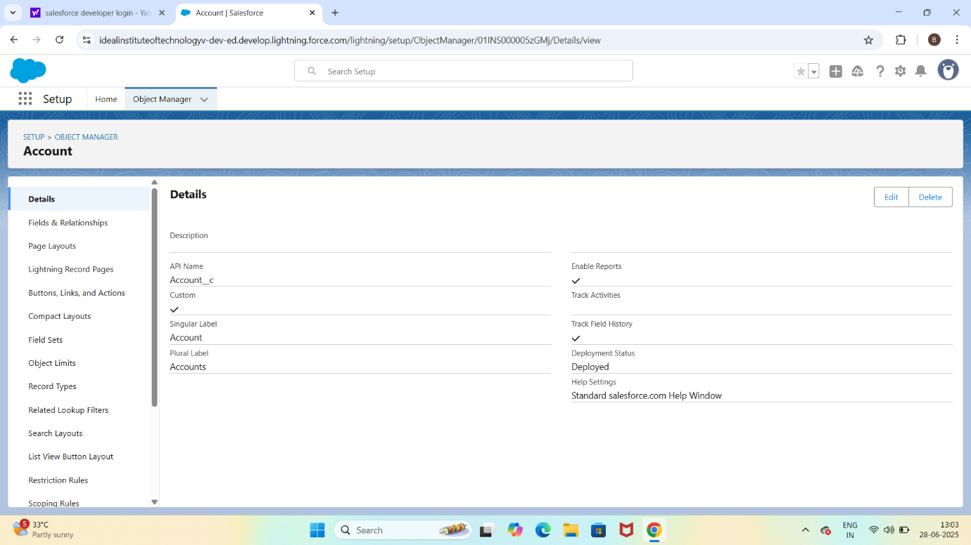

Appointment:
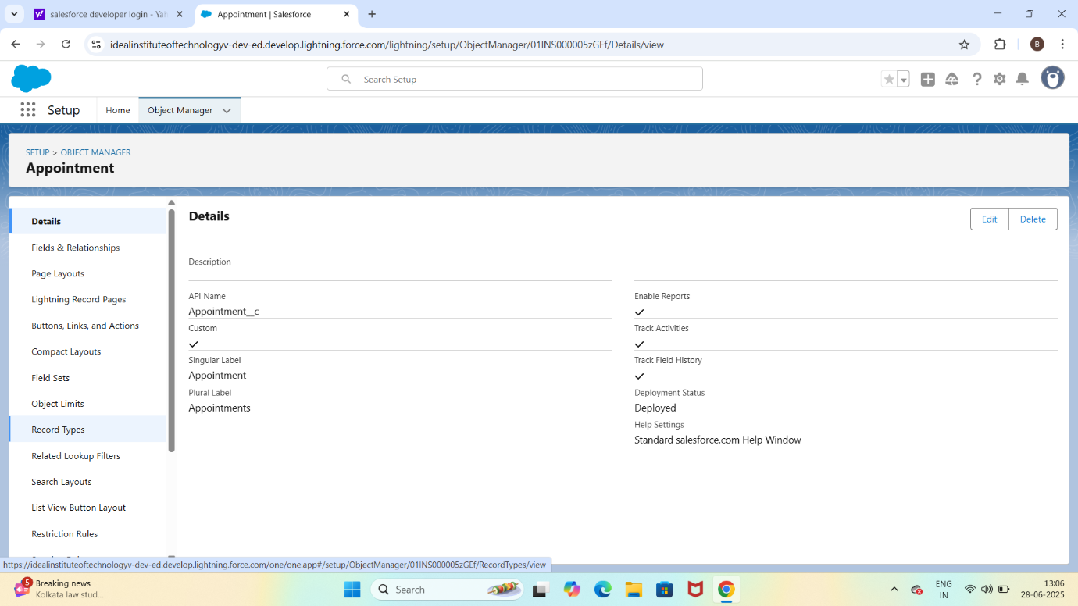
B.Custom Tabs and APP:
Tabs for each object

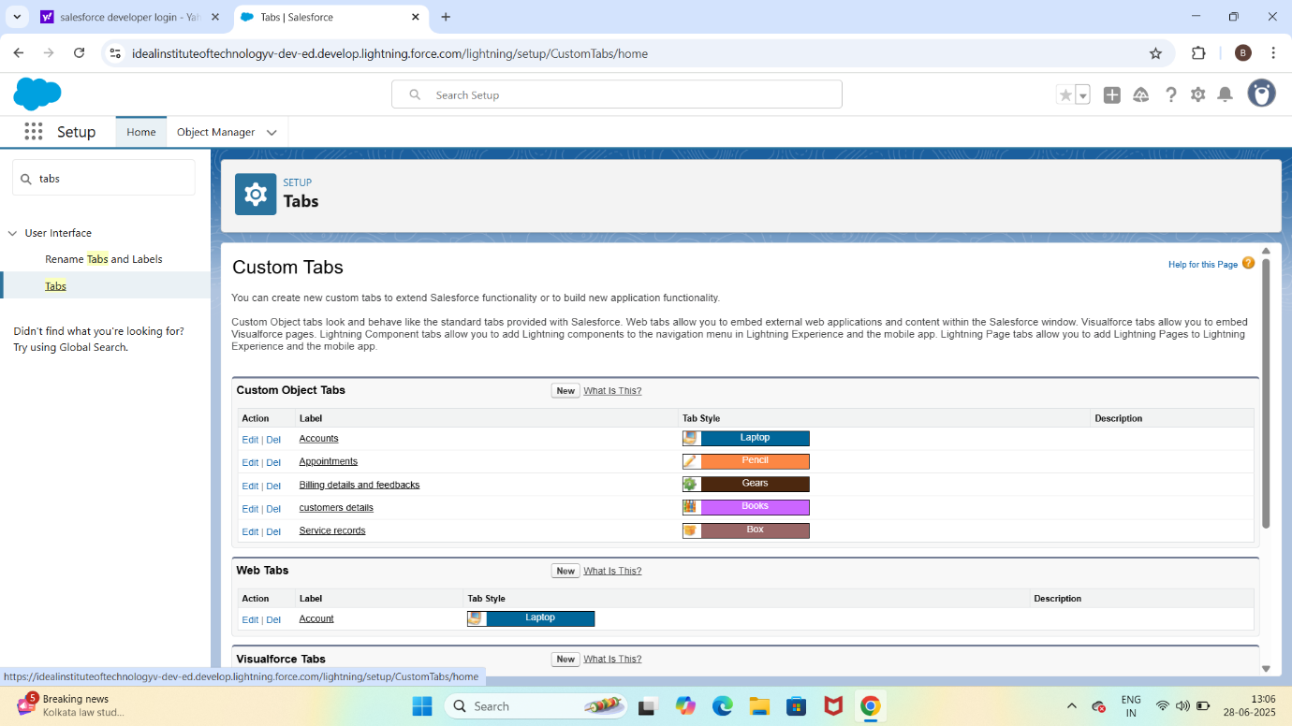

Lightning app:
A lightning app called lease management with navigation setup

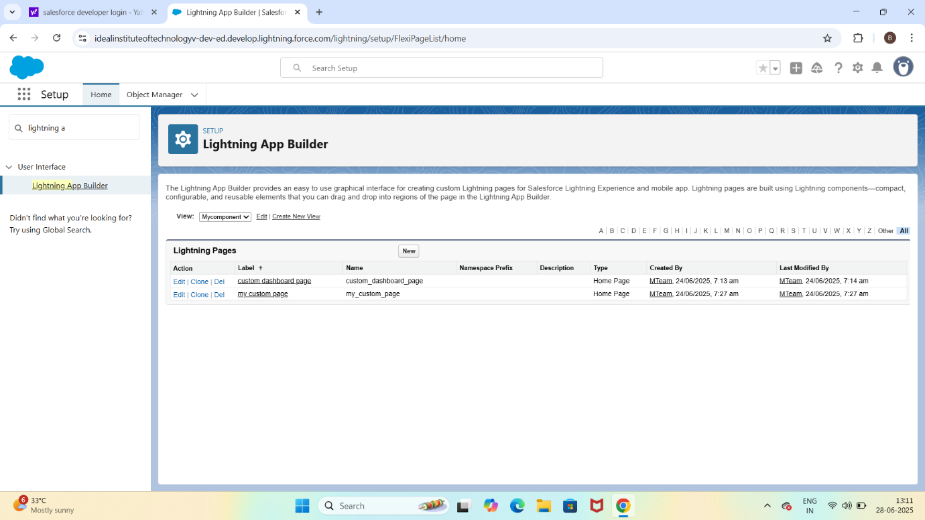

C.Fields and Relationships:

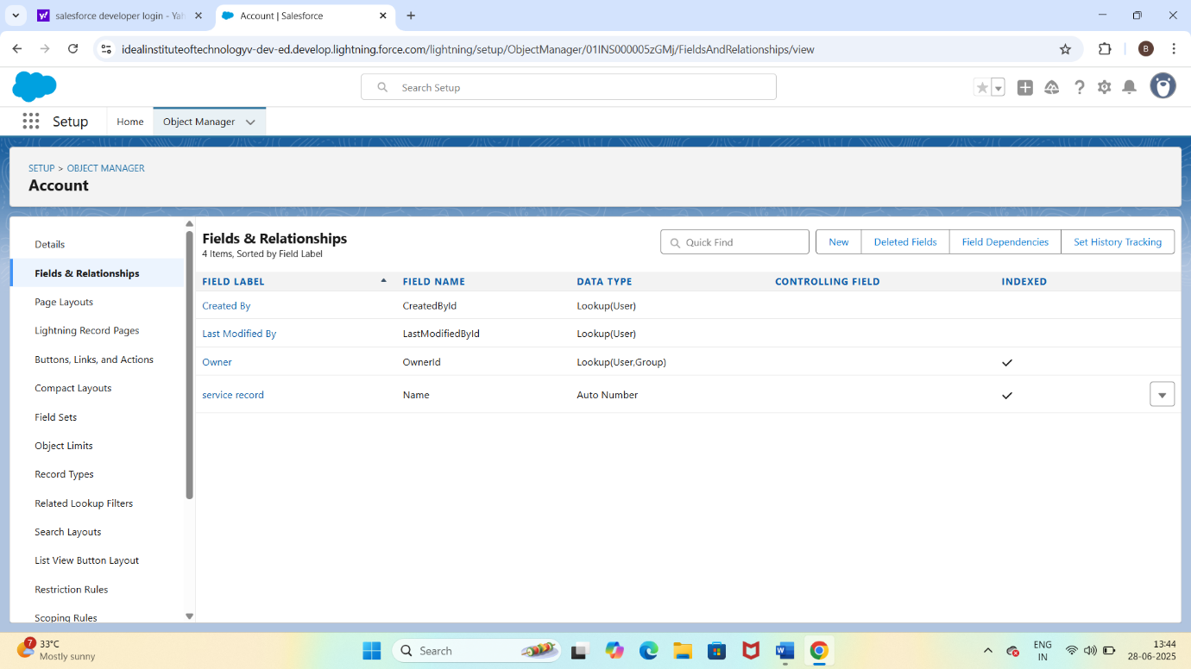

D.Apex Code(Custom Backend logic):

Apex Class: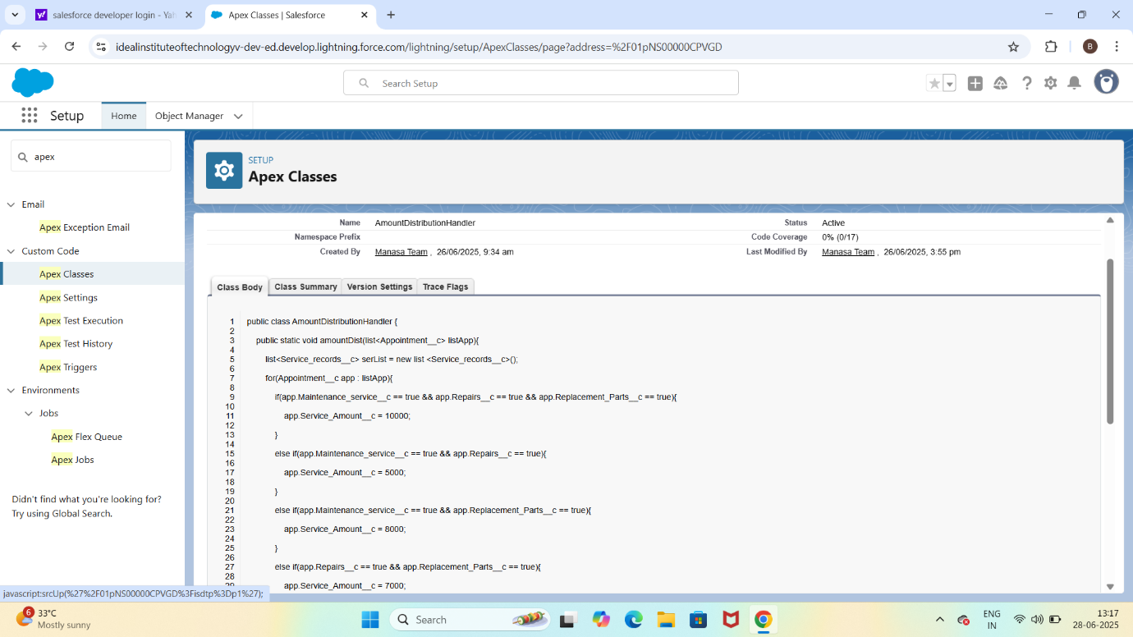

Apex Trigger:
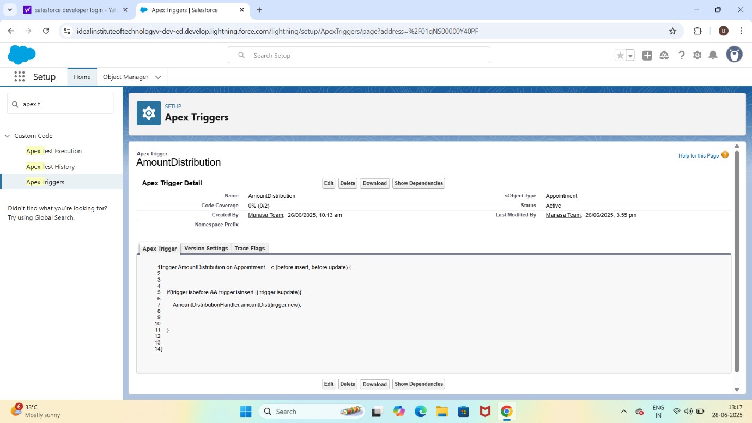

E.Validation Rule:
Appointment object has a rule: End_date__c > Start_date__c
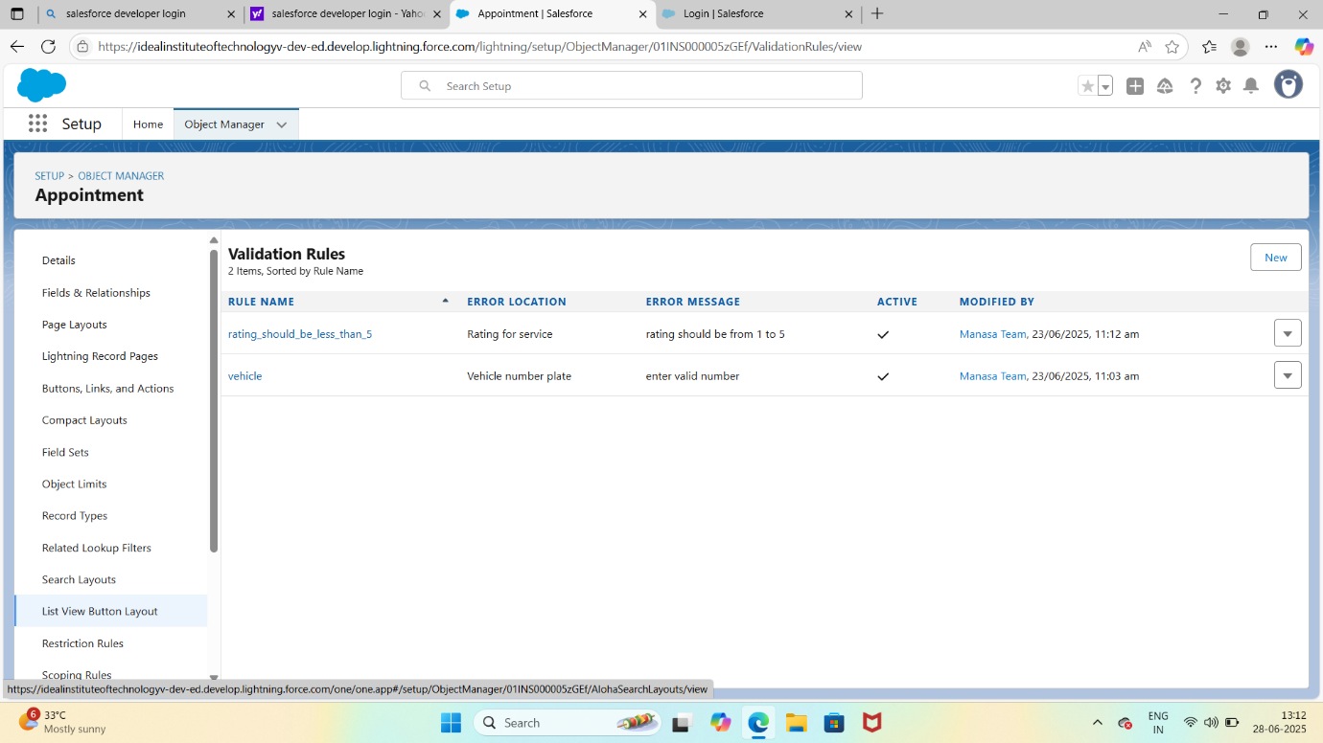
F.Flows:
